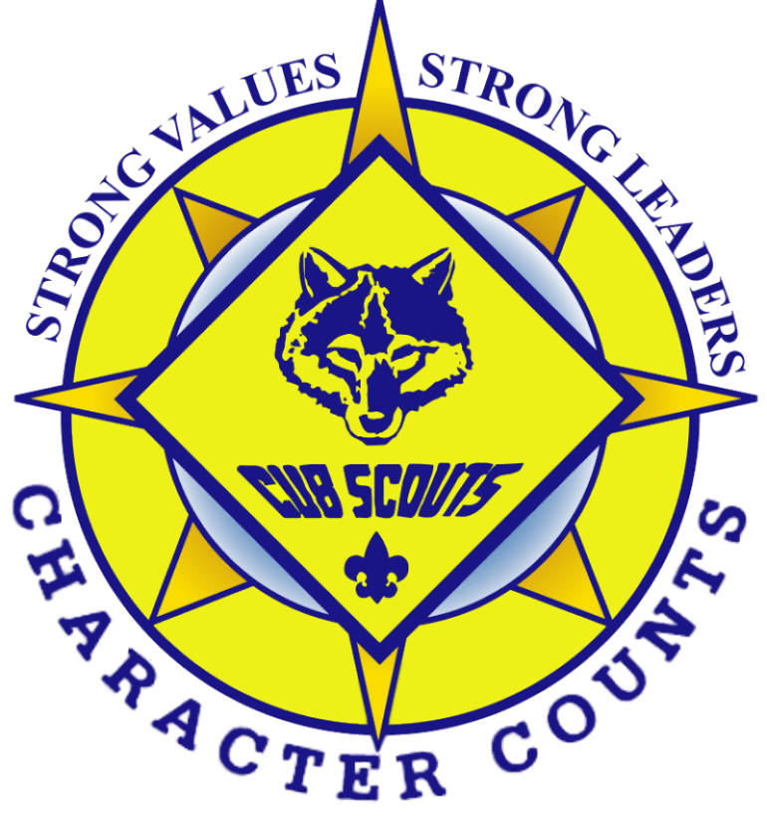

Pack 107
Parent Guide

Pioneer District ⋅ Golden Empire Council ⋅ Boy Scouts of America

Parent and Friends of 107 Chartered Organization

January 2014

Table of Contents

Committee Chair Welcome 1

Charter of Pack/Troop/Crew 107 2

A Brief History of Pack/Troop/Crew 107 4

Purposes of Cub Scouting 5
Principles of Character Development 5

How Cub Scouting is Organized 6
Chartered Organization 6
Cub Scout Pack 6
The Den 7
Pack Organization Chart 8

The Pack Committee 9
Leader & Family Responsibilities 9
Committee Leader Duties & Responsibilities 9

Cub Scout Leader Training 13

Parent Responsibilities 13

Uniform & Insignia 14

Finances 15
(Dues, Fundraisers, Scout Accounts, Friends of Scouting)

Internet Resources 17

Code of Conduct 18

Unit Discipline 18

Peacemakers Pledge 20
Committee Chair Welcome

Welcome to Cub Scout Pack 107. We are happy to have you join our pack. The quality of a Cub Scout’s experience depends greatly upon the level of involvement of both the Scout and his parents. A Cub Scout Pack is run by the Cub Master, who in turn is supported by his Assistant Cub Master, the Pack Committee, and non-registered parents. All the adults are volunteer parents just like you.

Because the best packs have a high ratio of active adults to Cub Scouts, we expect parents to participate in pack activities to make our pack successful. It is written within our Charter that one parent join scouting with his son by registering and being involved in Pack activities. These activities can include assisting the Den Leader during den meetings, field trips, leadership positions, event planning, or fundraising.

We look forward to getting to know you and your son better and hope your experiences here take you all the way to Eagle!

Troop 107 Committee Chair

CHARTER OF PACK/TROOP/CREW 107
Effective January 1, 2014

Charter Organization Executive Officer: Dave Hyde
Charter Organization: Parents and Friends of 107
Pack/Troop/Crew Charter Organization Representative: David Hyde
Pack Committee Chair: Caryn Frazier
Troop/Crew Committee Chair: Marcel Weiland
Cubmaster: David Pesenti / Scoutmaster: Rob Champe / Crew Advisor: Ronson Stotelmeyer

Pack/Troop/Crew 107 has been organized by Parents and Friends of 107 for the specific purpose of reinforcing the education of the Scouts who are homeschooled. Parents and Friends of 107 is the Chartering Organization. Pack/Troop/Crew 107's primary outreach for recruitment is to the Private Christian Homeschooled Community. The primary mission of Parents and Friends of 107 in implementing the Boy Scout program is to build positive moral character and good citizenship in our sons and daughters in an outdoor setting. Secondary purpose for the Pack, Troop and Crew is fellowship between families with similar vision for upholding God's holy scriptural standards for living. Permission was gained by Hope Chapel, Troop 107’s original Chartering Organization, and from the Boy Scouts of America/Golden Empire Council at the outset to adapt the scouting program as the Chartering Organization deemed necessary.

The following statements represent the guidelines of the Chartering Organization, joining Pack, Troop or Crew 107 constitutes your willingness to abide by its leadership and guidelines.

- The Pack/Troop/Crew is a ministry with its primary mission being to encourage establish, maintain and nurture a relationship with THE LORD JESUS CHRIST. The secondary emphasis is the scouting program itself. The scouting program is to be a tool, but is never to eclipse the original focus.

- The leadership committee of the Chartering Organization is to be the final authority in all Pack/Troop/Crew decisions and directives. The leadership committee of the Charter Organization consists of the Charter Organization representative, Committee Chair and Unit head of each unit.

- The Cubmaster, Scoutmaster and Crew Advisor are to be chosen by the unit Committee and approved by the Charter Organization.

- The Cubmaster, Scoutmaster and Crew Advisor, along with Den Leaders, Assistant Den Leaders, Assistant Cub/Scoutmasters, Committee Members with jobs and Committee Chairman are required to go to Basic Leadership Training.

- Training occurs twice a year, generally spring and fall. Contact the Training Coordinator for more details. It’s called New Leader Essential Training and Introduction to Outdoor Skills.

- The Pack/Troop/Crew Committee for each unit is to be comprised of active parents and/or Charter Organization members who have an interest in the spiritual development of the boys and who are members of Boy Scouts of America (BSA) and have completed Cub Basic and Boy Scout Basic Training. Only those members who meet these requirements have a vote in the Committee. It is also recommended that all pack and troop members go to Basic Adult Leadership Training or do such training online.

- A Parent from each scouting family (registered with BSA or not) will take part in the organizational running of the pack or troop or crew. The Committee Chairman will have a list of opportunities that each parent can choose from. The Charter Organization requires that at least one parent from each family register with the BSA and go to Basic Adult Leadership Training or do such training online.

- The Troop Chaplain will be approved by the leadership committee of the Charter Organization. The Chaplain is empowered to conduct religious services when outings coincide on Sundays or has an emphasis in the training at hand.

- The Charter Organization has decided that members of the Troop and Crew may participate in the Order of the Arrow. However, to the extent that any activities of the Order of the Arrow reflect elements of American Indian religions, Indian rites, nature worship, gods of the elements, etc, the Troop and Crew as a unit will not participate in such activities. It is understood that membership in Order of the Arrow is only through nomination by the Troop /Crew leadership with the approval of the Scout’s/Crew member’s parents. Whether or not an individual member of the Order of the Arrow from the Troop or Crew participates in a particular activity of the Order of the Arrow is up to the discretion of the Scout/Crew member and his or her parents.

- By joining Pack/Troop/Crew 107 and by signing this document, one agrees to abide by biblical standards of conduct in all areas of involvement with the units as contained in the unit handbook on page 18.

- By signing this document one agrees to abide by the Pack, Troop & Crew Unit Discipline as contained in the unit handbook on page 18.

- By signing this document one agrees to abide by the Peacemakers Pledge for biblical conflict resolution as contained in the unit handbook on page 20.

In order to become a youth or adult member or to continue in membership of Pack/Troop or Crew 107 one must agree to abide by the above by signing and dating this document.

_______________________________ _________________________
Registered Parent Date

NEW MEMBERS

In order to become a member of Pack/Troop/Crew 107, one must be sponsored by an existing member of the Pack/Troop/Crew 107 OR be a member in good standing of Sacramento Christian Organization of Parent Educators (SCOPE) or a member in good standing of the Home School Legal Defense Organization (HSLDA). One must obtain the signature of the current member of Pack/Troop/Crew 107 or list the membership number of either SCOPE or HSLDA.

___________________________________
SCOPE or HSLDA membership number

___________________________________ ___________________________________
Current Member Sponsor (printed name) Signature of Current Member Sponsor

A Brief History of Pack/Troop 107/Crew 107

Originally founded in the late 1980s as a ministry of Christian Outreach Fellowship in North Sacramento, Troop107 was re-activated by Pastor Bob Hall in 1991 as a homeschool Christian troop. Pastor Bob was thrilled to find out that Jim Pickens was an Eagle Scout, and the two men worked together to establish the vision for the Troop that we now know. Jim grew up in Scouting and his dad, John, had been the Scoutmaster. John had grown up during the Depression, hunting and fishing in the Oregon woods. John Pickens taught his troop as much about the outdoors as he could. Their troop had distinctive neckerchiefs, similar to the red bandanas Troop 107 wears today, that outwardly set them apart from other troops.

In October 1991, Christian Outreach Fellowship chartered Troop 107 in the Crazy Horse District with seven boys and five adults. Jim Pickens was the first Scoutmaster; his son Jonathan, a First Class Scout, was the first Senior Patrol Leader, serving from October 1991 through November 1992. He was followed by his younger brother Jason, who later became the troop’s first Eagle Scout on August 19, 1994. Jonathan became the troop’s third Eagle Scout on October 7, 1994. Since then more than 70 Troop 107 Scouts have made Eagle. Jim’s wife, Judy, served as Secretary, Treasurer, Popcorn Kernel, Advancement Chair, and Registrar, helping in any way she could to support the troop.

Hope Chapel became the new chartered organization for Troop 107 in September 1995 when Christian Outreach Fellowship closed its doors. Two years later, Eric Smith, who had caught the vision for the Scouting program as an Assistant Scoutmaster, became Troop 107’s second Scoutmaster. In September 2000, Scott Dawson, Committee Chair for Troop 107, launched Pack 107 and served as its first Cubmaster. The Ladies and Men Crew were soon to follow. Today, Pack, Troop and Crew 107 serve more than 100 Scouts and their families in the Golden Empire Council (GEC), Pioneer District. We encourage parents to get involved in Scouting activities to help make our pack and troop successful. As a result of strong parental involvement, our Scouts excel in advancement and at Camporee and other District events. The number 107 is highly regarded throughout the GEC.

Troop 107 Scoutmasters Pack 107 Cubmasters Crew 107
1991 Jim Pickens 2000 Scott Dawson 1998 Scott Dawson
1997 Eric Smith 2001 Mark Newitt 2000 Jim Colard
2003 Gary Abrams 2004 Greg Prichard 2008 Mark Newitt
2005 Larry Bosh 2007 Bob Herguth 2012 Dave Hyde
2006 Mark Newitt 2010 Andy Haug 2014 Ronson Stotelmeyer
2008 Jim Farrell 2011 Paul Dougan
2011 Greg Prichard 2014 David Pesenti
2014 Rob Champe
Purposes of Cub Scouting
The Cub Scouting program has 10 purposes related to the overall mission of the Boy Scouts of America – to build character, learn citizenship, and develop personal fitness:
- Character Development
- Spiritual Growth
- Good Citizenship
- Sportsmanship and Fitness
- Family Understanding
- Respectful Relationships
- Personal Achievement
- Friendly Service
- Fun and Adventure
- Preparation for Boy Scouts

Every Cub Scouting activity should help fulfill one of these purposes. However, not everything in Cub Scouting has to be serious – far from it! Silly songs, energetic games, and yummy snacks all have their place in the program.

Principles of Character Development
Character is a collection of core values a person possesses that lead to principled, moral commitment and action. It defines why we do what we do when we’re faced with a moral or ethical decision.

Three principles underlie character development: a set of core value; an understanding that character includes thought, commitment, and practice; and an emphasis on character in all aspects of life. Cub Scouting promotes 12 core values in helping boys develop character:

- Citizenship
- Compassion
- Cooperation
- Courage
- Faith
- Health and Fitness
- Honesty
- Perseverance
- Positive attitude
- Resourcefulness
- Respect
- Responsibility

These values are at the core of what it means to be involved in Scouting. If Cub Scouts are to be honest, responsible, courageous, and all the rest, leaders must be as diligent and skilled about teaching these values as they are about teaching the other aspects of the program. Each month a core value is highlighted within Cub Scouts and should be part of your monthly activities.

To find out more about the purpose of Cub Scouting, its ideals, methods and how to promote the core values, refer to the Cub Scouts Leader Book, found at your local scouting store.

How Cub Scouting is Organized

The Chartered Organization
The Council and District support the boys in the Cub Scout program through the pack, but they don’t run it. The responsibility of running units falls to a character organization who has received a charter from BSA to use the scouting program as part of its service to young people. The Chartered Organization does the following:

Provides a meeting place
- Selects a Scoutmaster
- Appoints the Troop Committee
- Chooses a Chartered Organization Representative

The Cub Scout Pack
The pack is the scouting unit that conducts the Cub Scout program for the chartered organization. It is led by a pack committee (made up of parents) which oversees administration functions and a Cubmaster who oversees program activities. The pack includes all the boys, leaders, and parents involved in cub scouting at the chartered organization.

A pack meeting is held monthly and led by the Cubmaster with the help of other adult leaders. It’s the pinnacle of the month’s activities and is attended by all boys and their parents and other family members. This is where the monthly achievements for each scout within their den are awarded. This is an award ceremony, and should be treated as such showing courtesy and respect for those scouts and leaders when they are on stage. It is also a fun time to celebrate. Dens can participate by providing a skit, tell jokes or show off some of the items they worked on during the month. The Cubmaster may also use this time to review the monthly character value or play a game as a pack. Many pack meetings usually conclude with a social time for all scout families.

A Pack meeting will typically follows this format:

- Opening Prayer and Flags
- Announcements
- Den Awards and Recognitions (may include skits/songs by each den)
- A Cub Master led game
- Closing Prayer

In Pack 107, setup, opening, closing, and cleanup are handled by the “Den-of-the-Month”. A yearly Pack calendar determines the “Den-of-the-Month”. These are the basic duties of the “Den-of-the-Month”:

- Bring flags.
- Get there early and set up at 6:30.
- Flags.
- Put away chairs.
- Put flags away.

The Den
The Cub Scout pack is divided into smaller groups by age into Dens.
- Tiger Cubs (first grade or 7 years old)
- Wolf Cubs (second grade or 8 yrs old)
- Bear Cubs (third grade or 9 yrs old)
- Webelos Scouts (fourth & fifth grades, or 10 yrs old)

Most packs have a den for each grade level, while some may have more than one (2 wolf dens, for example). Smaller packs may combine the fourth and fifth grades into one Webelos den, while larger ones may separate the 1st year from the 2nd year Webelos.

Dens typically consist of 6-8 boys. The size and structure lets boys build relationships with each other and with leaders. It gives boys leadership opportunities and the chance to do activities that would be difficult with the larger group.

Pack 107 dens meet the first 3 weeks of the month (or four weeks of the month if the month has 5 Tuesdays) and hold the Pack meeting the last week of the month. All of our meetings start together as a Pack for a flag ceremony, prayer, announcements, and then dens are dismissed to do their separate activities. Each den rotates the responsibility of opening our meetings. It is important to arrive on time to meetings
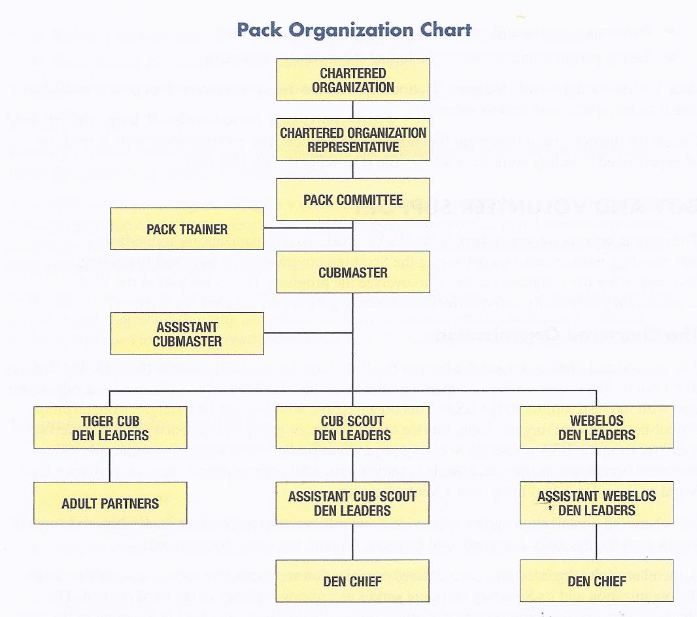

For more information on Pack relationships with the Council, District, Chartered organization, please refer to the Cub Scout Leader Book.

The Pack Committee

This committee oversees the activities of the pack. It is, essentially, all the parents registered as BSA Committee Members. Along with the Chartered Organization Representative, the committee works on behalf of the chartered organization to ensure that the pack operates within the organization’s policies. The committee establishes the overall goals of the pack, determining what they want the boys to get out of Scouting and the means to carry out the goals of the pack and the pack charter. Pack 107 has a self-charter, Parents and Friends of 107; their primary mission is to build positive moral character and good citizenship in our sons in a setting that emphasizes outdoorsman skills and citizenship. A secondary purpose is to arrange fellowship among boys from families with a similar vision for upholding God’s holy scriptural standards for living.

Leader and Family Role Responsibility
No single person can make a Cub Scout Pack work. Instead it takes a pack leadership team that includes the Cubmaster, Assistant Cubmaster, Pack Committee Chair, Den Leaders and Assistants, Den Chiefs, and Committee members (which are the parents of the cub scouts). You guessed it, that includes EVERYONE!!

Each leader has a specific role within the pack, while we all share the responsibility to ensure our boys have a positive, fun, adventure during their time with Cub Scouts. Below are details to each leadership position, as well as responsibilities for all of our parent Committee members.

Duties and Responsibilities - these are brief descriptions. For a full understanding of the scope of each role, please refer to the Cub Scout Leader Book or make an appointment with the Scoutmaster.

Chartered Organization Representative
- Is a member of the chartered organization
- Serves as head of “Scouting Department” in the organization
- Encourages the unit committee to hold meetings.
- Serves as a liaison with both the Pack and Troop Committee Chair, and the two units in general

Pack Committee Chair
- Leads the pack committee and thus is responsible for the administration, oversight, and support of the pack program
- Maintains a close relationship with the Chartered Organization Representative and chartered organization
- Interprets national and local policies to the pack
- Contributes to the preparation of pack committee meeting agendas

Pack Committee Member
- Make recommendations regarding pack leadership to the Leadership meeting
- Coordinate the pack’s program and then provide support to leaders in carrying out the program
- Ensure that all Cub Scouts receive a quality program
- Help stimulate the interest of adult family participation and volunteerism.
- Supervises finances and equipment

Cubmaster
- Should be a leader who is able to communicate well with adults as well as boys.
- Plan and help carry out the Cub Scout program in the pack according to the policies of the BSA. This includes leading the monthly pack meeting, with the help of other leaders.
- With the pack committee, develop and execute a year-round recruitment plan for recruiting boys into Cub Scouting.

Assistant Cubmaster
- Help the Cubmaster as needed. Able to replace the Cubmaster in cases of emergency or absence.
- Participate in Pack meetings
- Help with pack activities, such as dinners, derbies, bike safety workshops, and service projects
- Participate in the annual pack program planning meeting and leaders meetings.

Cub Scout Den Leaders work directly with Cub Scouts and their parents to execute the Cub Scouting Program by doing the following:
- Work directly with other den and pack leaders to ensure that the den is an active and successful part of the pack.
- Plan, prepare for, and conduct den meetings with the assistant den leader and den chief (if applicable) or adult partners.
- Attend the Pack Leaders monthly meetings.
- Lead the den at the monthly pack activity/meeting.

Assistant Cub Scout Den Leader shares the responsibilities of the Cub Scout den leader and may be called upon to serve as a family contact or record keeper, or to handle other details of den operation. Each den should have at least one assistant den leader.

Membership Coordinator is essential to the health of the pack:
- Develop, with help of pack leaders, a plan for year-round membership growth (i.e. advertisements)
- Plan, coordinate, and lead the annual rechartering process
- Assist the Pack Trainer with orientation of all new pack members.
- Works with Troop Membership Coordinator to prepare Webelos II for transition into Troop
- Work with secretary in keeping pack roster up-to-date

Secretary ensures proper records are kept within the pack:
- Keeps informed of all cub scouting literature, records, forms to help leaders function effectively.
- Acquaint den leaders with the Pack Record Book (this could be an advancement duty since records are normally kept for the purpose of advancements)
- Maintain up-to-date info on membership, leadership, attendance, and advancement (an example of how checks and balances work within the Pack)

Treasurer ensures the pack’s finances are sound through the following:
- Opens/maintains bank account; transactions to be signed by any two of the following: cubmaster, pack committee chair, or treasurer
- Approves all budget expenses; pack committee chair should approve bills before payment
- Collects dues; deposits money

Advancement Chair helps boys move through the ranks of Cub Scouting through the following:
- Have a working knowledge of the advancement plan
- Promote the use of cub scout den advancement chart and other tools to recognize a record advancement in the den
- Collect den advancement reports for use when ordering badges and insignia from the local council service center
- Needs to feel comfortable on a computer to input into council site

Pack Trainer has the goal to get 100 percent of the pack leadership trained in their position responsibilities through the following:
- Ensure that all new leaders and adult family members receive an orientation within one week of joining the pack. This is in collaboration with the Membership Coordinator.
- Encourage pack leaders to attend Fast Start training, Position-specific leader training, This is Scouting, and Youth Protection training. Leaders should be encouraged to receive position-specific training within 30 days.

Outdoor/Activities Coordinator
- On the lookout for volunteers to coordinate Pack events such as Twilight Camp, Eternal Flame, Blue & Gold Dinner, Pinewood Derby, and other Pack Activities.
- Oversees Pack events

Equipment Coordinator
- Works with the Pack Committee to do the following:
  - Ensure all pack equipment is properly maintained
  - Ensure the pack equipment is securely stored
  - Determine what new equipment is needed
  - Acquire equipment he and/or the pack committee determines is needed

Clothes Closet
- Maintains the clothes closet, discarding outdated uniforms or Pack T-shirts that are torn or stained.
- Also takes orders for the Pack Class B T-shirt each fall. Collects money to be turned into the Treasurer, places order, and disperses t-shrits.

Popcorn Kernel or assistant to the Troop Kernel
- This is normally a position where you coordinate sales with both the Troop and Pack, although it could be divided among volunteers. It is our largest fundraiser and requires a good 6 month commitment to complete the job.
- Attend the annual popcorn training put on by the Golden Empire Council held mid-summer (usually June).

Refreshment Coordinator
- Responsible for coordinating refreshments during monthly Pack meeting.
- Send out an announcement to the Pack before each Pack meeting asking families to bring a refreshment item.

Pack Webmaster
- Maintain Big Tent website for Pack 107

Cub Scout Leader Training

Every Cub Scout deserves trained leaders because those leaders are best able to provide a quality scouting experience – and because training makes the leader’s role easier and more enjoyable. Most training can be done on-line through BSA and only need to be taken once. Some training expires and must be re-taken in order to renew your membership with the pack. Before your application will even be processed you must show proof of your Youth Protection training. Go on-line to https://myscouting.scouting.org to set up an account to access and record all your on-line trainings completed. Keep your user name and password in a safe place. Do not make the mistake of creating another account the next year! This will mess up your records of what trainings have been completed! Below are some of the recommended courses:

- Youth Protection – immediately required for all registered adults and must be renewed every 2 years at the time of the Pack Chartering. Print your certificate and hand in to the Pack Membership Coordinator. She cannot turn in your application until she has a certificate of completion in hand.
- Fast Start Training – designed to help you find out about the Boy Scout program and the specific responsibilities of the positions available to adult leaders.
- This is Scouting – highlights the values, aims, history, funding, and methods of the Scouting program.
- Leader Position Specific Training provided for den leaders, committee members, Cubmasters/Assistant Cubmasters, and pack trainers

The BSA has adopted the following policies for added security and protection of pack members. These policies are covered in depth in Youth Protection Training.

- Two-deep leadership
- No one-on-one contact
- Respect of privacy
- No secret organizations
- Appropriate attire

As a further action to staying informed, the Council sponsors monthly Roundtable district meetings designed to discuss ideas, share resources, and solve problems. Parents are highly encouraged to attend.

Parent Responsibilities
Families play a central role in Cub Scouting, a role that goes far beyond just getting boys to and from meetings and sewing on patches. At its heart, Cub Scouting is a family program, involving parents and often siblings in most activities. The family is the place boys learn and practice the core values of Cub Scouting, like cooperation, faith, honesty, and responsibility. Scouting works best when it works with parents to reinforce these values and to strengthen relationship among family members.

At the same time, families have much to offer the pack. They are the primary source of pack leaders, of course, but even those who never sign on as leaders can support the pack, den leaders, and Cubmasters in critical ways.

Scouting makes no secret about how parents should be involved. On the Youth Application is a short parent agreement, where parents commit to participate in meetings and activities, help their sons grow as Cub Scouts, and assist pack leaders as needed.

Here are some examples of family involvement:
- Work with your cub scout on advancement projects and activities outside of den meetings as needed
- Read the general requirements for advancement in your son’s handbook for his rank so that you know how to help him.
- Attend pack meetings with your cub scout and support recognition ceremonies
- By arriving at all meetings on time, you are modeling the core values of respect and responsibility.
- Become a leader within the pack
- Provide ways for your Cub Scout to earn money he needs for his uniform, dues, or other Cub Scout outings/activities. This can be done by helping your scout participate in pack fundraisers.
- Sign up to help at an occasional den meeting on a specific project or activity badge
- Help den leaders maintain order and quiet during pack meetings by setting the example for the Cub Scouts.
- Provide refreshments and transportation if needed.
- Volunteer to telephone or email reminders for your den
- Attend a council-organized family campout with your Cub Scout
- Attend a pack overnighter if offered.

Uniforms and Insignia

Leaders and youth members wear a BSA uniform because it is a means of identifying openly with the principles and aims to which they are committed: character development, citizenship training, and physical and mental fitness. It is a way to give each other strength and support, a bond that ties them together in making visible their commitments to a belief in God, to being loyal to country, and to helping other people.

Class A uniforms should be worn to all den and pack events. This includes the scout shirt, hat, neckerchief and slide, belt. The shirt should always be tucked into the trousers. Our pack does NOT require the purchase of shorts/pants and socks. Scouts can wear any blue pants/shorts, including jeans, but should maintain the blue color guideline (no camo is allowed per BSA policy). Class A uniforms can also be worn to a council wide product sale or event authorized by the local council executive board, such as Scout Sunday in early Feb of each year.

The Class B uniform (pack t-shirt) can be worn when directed by your Den leader, usually for activities requiring more freedom of motion, messy craft night, or certain outdoor activities. Regardless of the type of uniform, it should be neat, clean, and ironed.

A Cub Scout uniform may NOT be worn in the following circumstances:
- To advertise any commercial product or business
- Involved in any distinctly political endeavor
- Appearing on stage professionally without special approval from the National Executive Board
- Taking part in parades, except when rendering service as a Cub Scout or Leader when officially representing the BSA
- Participating in demonstrations not authorized by the BSA

Cub Scout uniforms and other materials can be purchased at:
River City Scout Shop (located right behind the Golden Empire Council office)
251 Commerce Circle
Sacramento, CA 95815
916/649-1800

Pack T-shirts are ordered once a year through our Clothing Closet Coordinator.

Placement of patches can be found at the back of the scout handbook. While you can glue/iron on patches, it is highly recommended that you stitch them. The patches have been known to fall off when glued/ironed on and the shirts are not always able to be passed down to another scout should the glue leave a mark on the uniform.

Finances

The financial needs of a pack vary depending on its members and activities, but these are some of the expenses that every pack can expect to include in its budget:
- Yearly Pack Re-Charter Fee
- Registration
- Program Materials
- Activities
- Accident Insurance
- Rental fees
- Reserve Fund

Cub Scouts are expected to pay for their uniform, annual membership fee to the national organization, subscription to Boys’ Life magazine (optional, but encouraged), handbook, and monthly dues. The boys can use personal savings or money earned through fundraisers to pay for their Cub Scouting expenses. Money for the pack to pay for scout insignia and den activities comes from dues and fundraising projects.

Dues

Pack 107 collects pack dues and the annual BSA registration fee at Recharter time in the fall each year. The Membership coordinator hands out registration forms. Pack dues are $6.50 per scout per month with the option to make one payment, 6 months at Recharter and in June, or monthly. The pack treasurer deposits the dues into the pack’s checking account to be used to buy the patches, belt loops, and pins earned, as well as to cover the cost of some den activities. Dues must be kept current in order to receive rank advancement, and other special awards. A Cub Scout’s dues can be paid with the money he has accumulated in his Cub Scout account through fundraisers. Adult fees may not be paid with a Cub Scout’s account.

Fundraisers

Because dues are not enough to cover the costs of the program, the pack holds fundraisers to help pay for Scouting activities. Pack 107 fundraisers include Trail’s End Popcorn and See’s Candies in the spring.

When your son participates in a fundraiser, he will be responsible for collecting and holding all money earned through the fundraiser until the due date. Please do not turn in cash to the treasurer! You may accept cash from customers, but when turning in your money to the treasurer convert all cash and coins into a check. Our popcorn fundraiser, for example, earns over $15,000. We do not want our treasurer to have to count out and transport $15,000 in cash to the bank!

Scout Accounts

In Pack 107, when Scouts earn money through fundraisers, the portion of the money they keep is put in a virtual Scout account within the pack’s bank account. The Scout can use that money to pay directly for Scouting activities or can be reimbursed for Scout-related expenses by presenting a receipt to the pack treasurer. A scout account cannot be used to pay parents’ fees.

Friends of Scouting

Each year the district finance committee conducts a Friends of Scouting campaign, a presentation to parents to request financial support of the local council.

Internet Resources

There are many valuable sites to visit. Use your favorite search engine to find resources for anything from advancement requirements to comics. Below are lists of some of those resources which include information on advancement, pinewood derby, skits and activities, silly songs, etc. Remember to copy any information you want to keep onto your computer; if you only bookmark the sites, they might not be there when you look for them again.

- Pioneer District gec-bsa.org/districts/pioneer
- Golden Empire Council gec-bsa.org
- Boy Scouts of America National Council Scouting.org
- Boys Scouts of America Retail Store Scoutstuff.org
- Scouting Magazine Scoutingmagazine.org
- Boy’s Life boyslife.org
- Belt loop and pins info http://usscouts.org/advance/cubscout/a-sindex.asp
- Skits http://usscouts.org/skits.asp
- Skits http://www.boyscouttrail.com/cub-scouts/bear-scout-skits.asp
- Knots http://scoutingmagazine.org/issues/0901/a-knots.html#sbar1
- Web Activity Badges http://www.usscouts.org/advance/cubscout/webbadges.asp
- Cub Fun Pages https://people.creighton.edu/~bjs74318/bluejay/pack114/funpages/
- Scouting Resources Online macScouter.com
- Boy Scout Resources Scoutorama.com
- Scouter Interactive Scouter.com
- Scoutmaster Resources Scoutmaster.org
- U.S. Scouting Service Project usScouts.org
- Resources for Cub Scouts & Boy Scouts boyScouttrail.com
- Bryan on Scouting (blog) blog.scoutingmagazine.org

CODE OF CONDUCT

In recognition that all organizations must have a standard by which to measure their code of conduct, and in recognition that all members must be expected to adhere to the same code of conduct, I do hereby recognize that all units, being Pack, Troop, and Crew number 107 of the Golden Empire Council, Boy Scouts of America, have chosen to base all elements of their code of conduct using the foundational principles put forth in the Holy Bible.

As such, I agree, as a voluntary members of 107, that I shall conduct myself in a manner consistent with the values and standards described in the Holy Bible and implemented through the unit program at all times.

I recognize that 107 does not require a profession of Christian faith for membership, as required by BSA policy, but nonetheless agree to recognize these Biblical Christian principles as they apply to my conduct within the unit.

I also agree that any disagreement to the standards set forth by 107 leadership shall be discussed with the appropriate unit committee.

I also agree that should resolution not be achieved via the unit committee that the issue shall be brought to the unit charter organization. All decisions by the unit charter organization shall be final.

___________________________________________________________________________

PACK, TROOP & CREW UNIT DISCIPLINE

This process is taken and adapted from the Bible, specifically Matthew Chapter 18 on the Topic of Church Discipline. Questions or concerns about this information can be directed to the Chartering Organization Representative of the Crew, Pack and Troop. This document was created to stimulate the parents into thinking about Scout discipline.

I understand it is the parents who are the primary trainers of their children. However, all trained unit leaders are charged with the safety and protection of everyone in the Crew, Pack and Troop.

Discipline is first the responsibility of each Scout. Self-government and being responsible for ones actions is part of being a Scout. But if or when a Scout or Scouts gets out of line any adult can request the behavior or activity be stopped - especially when dealing with safety issues. For example, climbing a tree in the dark is not a good idea and for most questionable behavior a simple request to stop the behavior is all that will be needed.

If the parents are not available the Unit Leaders or adults in-charge will step in and deal with the immediate situation. A discussion with the parents to inform them of behavior issues or to express concern over safety issues or situations should happen as soon as possible. The parents should mentor, discipline or train their Scout or younger children in the appropriate behavior and safety issues.

If parents do not confront their child’s behavior with some sort of training and or allow bad behavior to continue, a conference with the involved scout(s) will be arranged with the appropriate Key 3 unit (the Cubmaster, Scoutmaster or Venture Crew Advisor, the Charter Representative and the Committee Chairman) and other adults who witness the behavior will take part in the conferences.

The goal of conferences is to address bad behavior and/or safety issues and to address the Scouts behavior in these issues. The Scout Oath, The Scout Law and the Guide To Safe Scouting are our guides for a Scouts Code of Conduct. The goal is changed behavior (Restoration) bringing it into the guidelines of the Scout Oath, Scout Law and the Guide to Safe Scouting.

Parents will take an active role in monitoring their child’s behavior for a period of time designated by the Key 3. Other Scout parents should also monitor the Scouts behavior especially issues of physical contact with other Scouts, verbal bullying or showing disrespect to adults and youth scout leaders.

Further action could be biblical counseling by Nouthetic Counselors in Roseville or the suspension from scout activities for a designated period of time with counseling. All suspensions must be unanimously approved by the Executive Committee.

If self-government cannot be restored, meaning the Scout will not act according to the Scout Oath, Scout Law and Guide to Safe Scouting, then the Charter Organization Representative can and will revoke the membership of the Scout and or Parents from its membership roll with the knowledge and approval of the leadership committee of the Charter Organization.

There is serious behavior that will immediately cause the permanent suspension g of membership and that is child abuse, sexual molestation and viewing pornography at a Scout event. Whether by Scout or adults these activities are considered by the Boy Scouts of America to be 100% not tolerated. If any adult engages in such behavior, the Charter Organization Representative will permanently suspend their membership in Pack//Troop/Crew 107 and the Scout Executive of the Golden Empire Council will be notified. The Scout Executive will conduct an investigation, which may include law enforcement. With respect to viewing or sharing pornography by Scouts, the Scout will be given a warning at the first offense. If the Scout engages in this behavior a second time, the Charter Organization Representative will permanently suspend their membership in Pack/Troop/Crew 107.

It is understood that a failure to abide by biblical standards of conduct as set forth in the Code of Conduct will be reviewed by other adults in the unit and by unit leadership and such instances will be discussed with the parties involved using the principles of Mathew 18. If direct discussion between the parties involved does not result in resolution of the issues, then the issue should be taken before the Key 3 of the units (Charter Organization Representative, Committee Chair and Unit Leader) or the unit committee. If at that point the person whose conduct or actions is at issue does not address the issue, then the persons involved may have their membership in the unit suspended for a period or suspended permanently.

PEACEMAKERS PLEDGE

A Commitment to Biblical Conflict Resolution
As people reconciled to God by the death and resurrection of Jesus Christ, we believe that we are called to respond to conflict in a way that is remarkably different from the way the world deals with conflict.¹ We also believe that conflict provides opportunities to glorify God, serve other people, and grow to be like Christ.² Therefore, in response to God's love and in reliance on his grace, we commit ourselves to respond to conflict according to the following principles:
Glorify God — Instead of focusing on our own desires or dwelling on what others may do, we will rejoice in the Lord and bring him praise by depending on his forgiveness, wisdom, power, and love, as we seek to faithfully obey his commands and maintain a loving, merciful, and forgiving attitude.³
Get the Log out of Your Eye — Instead of blaming others for a conflict or resisting correction, we will trust in God's mercy and take responsibility for our own contribution to conflicts—confessing our sins to those we have wronged, asking God to help us change any attitudes and habits that lead to conflict, and seeking to repair any harm we have caused.⁴
Gently Restore — Instead of pretending that conflict doesn't exist or talking about others behind their backs, we will overlook minor offenses or we will talk personally and graciously with those whose offenses seem too serious to overlook, seeking to restore them rather than condemn them. When a conflict with a Christian brother or sister cannot be resolved in private, we will ask others in the body of Christ to help us settle the matter in a biblical manner.⁵
Go and be reconciled — Instead of accepting premature compromise or allowing relationships to wither, we will actively pursue genuine peace and reconciliation—forgiving others as God, for Christ's sake, has forgiven us, and seeking just and mutually beneficial solutions to our differences.⁶
By God's grace, we will apply these principles as a matter of stewardship, realizing that conflict is an assignment, not an accident. We will remember that success in God's eyes is not a matter of specific results, but of faithful, dependent obedience. And we will pray that our service as peacemakers will bring praise to our Lord and lead others to know His infinite love.⁷
¹ Matt. 5:9; Luke 6:27-36; Gal. 5:19-26.
² Rom. 8:28-29; 1 Cor. 10:31-11:1; James 1:2-4.
³ Ps. 37:1-6; Mark 11:25; John 14:15; Rom. 12:17-21; 1 Cor. 10:31; Phil. 4:2-9; Col. 3:1-4; James 3:17-18; 4:1-3; 1 Peter 2:12.
⁴ Prov. 28:13; Matt. 7:3-5; Luke 19:8; Col. 3:5-14; 1 John 1:8-9.
⁵ Prov. 19:11; Matt. 18:15-20; 1 Cor. 6:1-8; Gal. 6:1-2; Eph. 4:29; 2 Tim. 2:24-26; James 5:9.
⁶ Matt. 5:23-24; 6:12; 7:12; Eph. 4:1-3, 32; Phil. 2:3-4.
⁷ Matt. 25:14-21; John 13:34-35; Rom. 12:18; 1 Peter 2:19; 4:19.
- See more at:
http://www.peacemaker.net/site/c.aqKFLTOBIpH/b.958159/k.A440/Peacemakers_pledge.htm#sthash.igQRlE06.dpuf

